Report on Car Price Prediction & Weather Classification

Regression Report (Car Dataset EDA)

1. Introduction
- Car dataset with features: engine_cc, mileage, year, assembly, body, color, fuel_type, make, model, transmission, ad_city, registered, price.
- Objective: Conduct EDA and preprocessing. (No modeling).

2. Data Cleaning and Preparation
- Missing Values:
  - assembly (53,261), body (8,865), color (1,510), fuel_type (934) → filled with "Unknown".
  - year (4,721), engine_cc (2), price (649) → filled with median.
- Categorical Encoding: One-hot encoding applied to non-ordinal columns (assembly, body, color, fuel_type, make, model, transmission, ad_city, registered).
- Normalization: Applied to ad_ref, engine_cc, mileage, year.
- Train–test split: 80-20 applied (even if no model is trained, ensures consistency).

3. Data Analysis and Visualization
- Summary Stats:
  - Median price ~4.5M PKR, wide variance due to luxury cars.
  - Mileage distribution skewed toward lower values for newer cars.
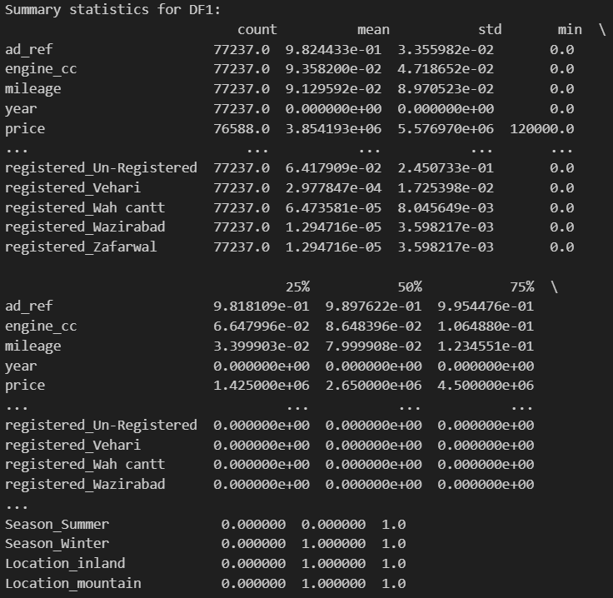
- Scatter Plots:
  - Year vs Price: Positive trend, newer cars → higher prices.
  - Engine CC vs Price: Higher engine capacity linked to higher prices.
- Correlation Heatmap:
  - Price strongly correlated with Year and Engine CC.
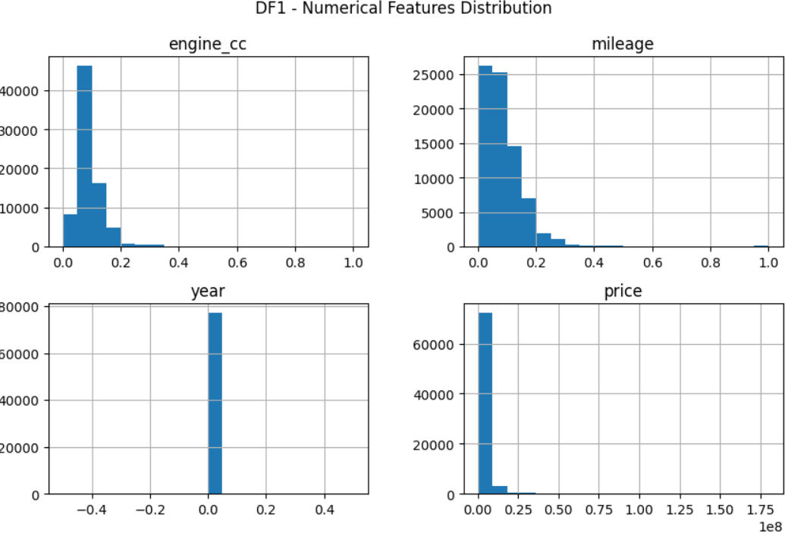
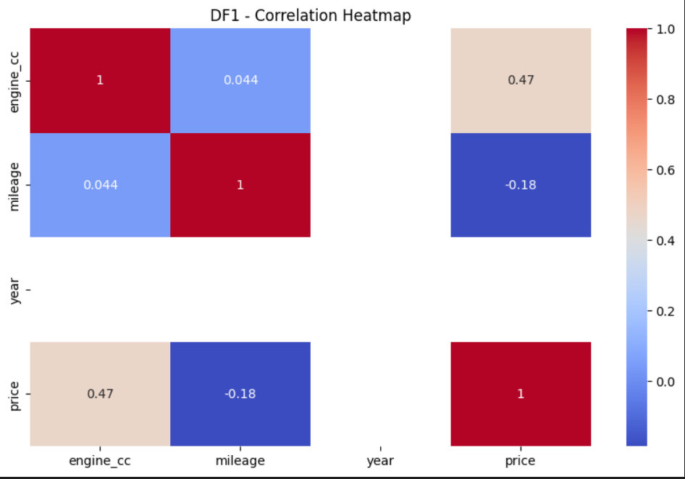
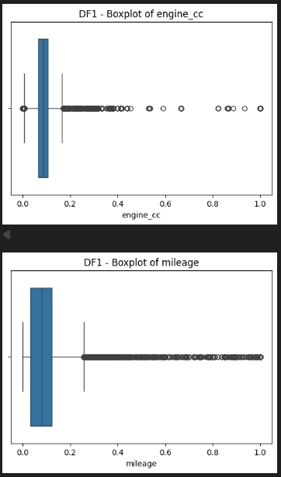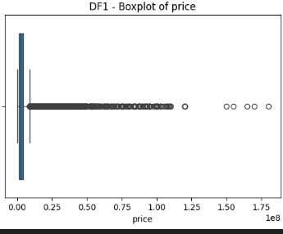
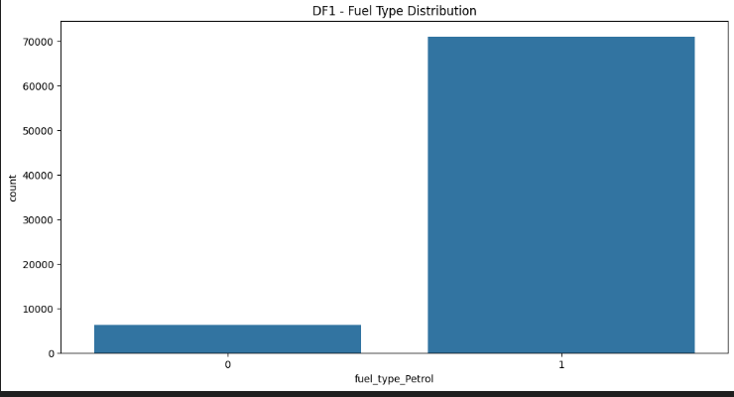
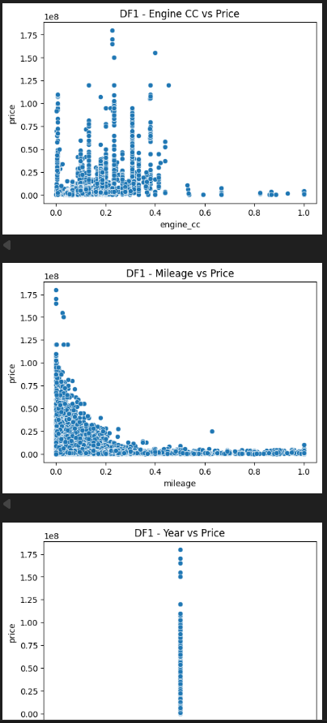

4. Conclusion
- Cleaning and preprocessing ensured dataset consistency.
- EDA showed newer cars, larger engines, and certain makes/models drive higher prices.
- This dataset is now well-prepared for future regression modeling.

Classification Report (Weather Classification)

1. Introduction
- Weather dataset with numerical + categorical features.
- Objective: Predict Weather Type using classification models.

2. Data Cleaning and Preparation
- No missing values.
- One-hot encoding for categorical features: Cloud Cover, Season, Location, Weather Type.
- Normalization applied to: Temperature, Humidity, Wind Speed, Precipitation (%), Atmospheric Pressure, UV Index, Visibility.
- 80-20 train–test split.

3. Data Analysis and Visualization
- Summary statistics revealed seasonal patterns (e.g., high humidity → high precipitation).
- Scatter plots: Temperature vs. Humidity (negative correlation), Humidity vs. Precipitation (positive correlation).
- Correlation heatmap confirmed strong feature interactions.
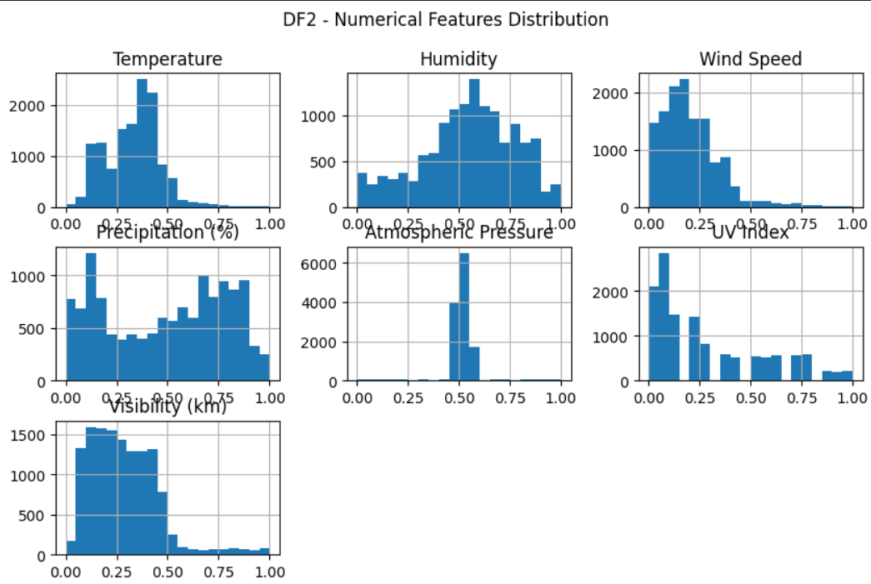
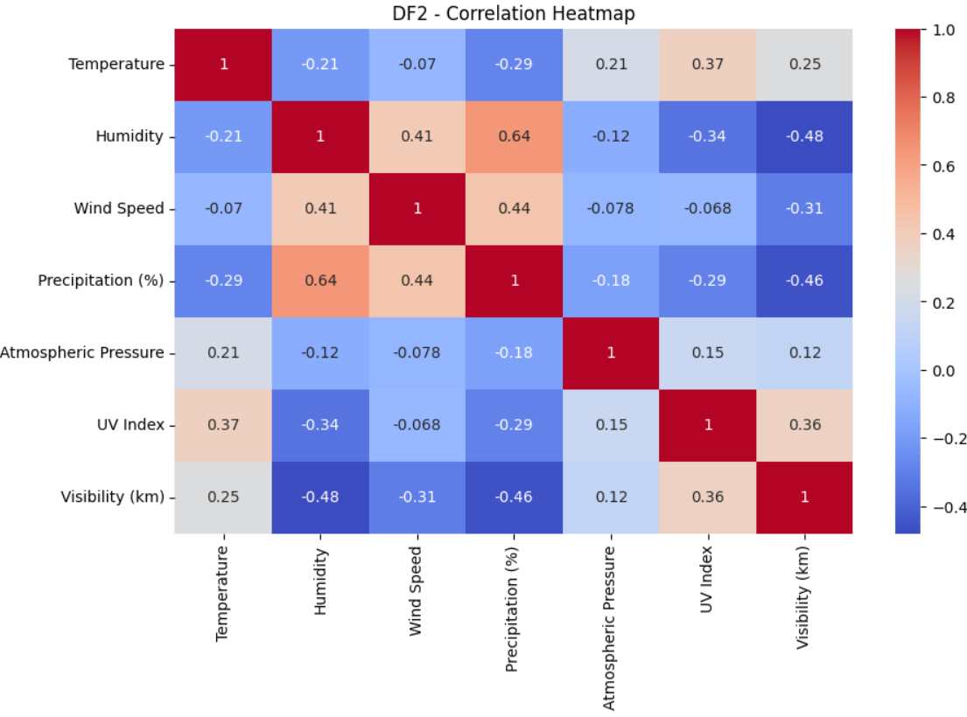
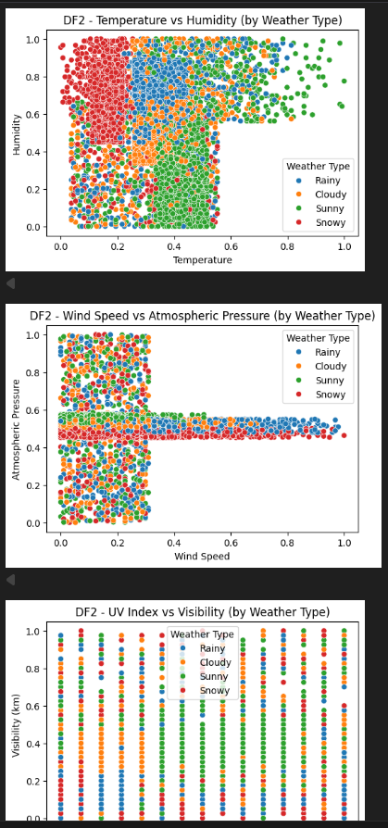
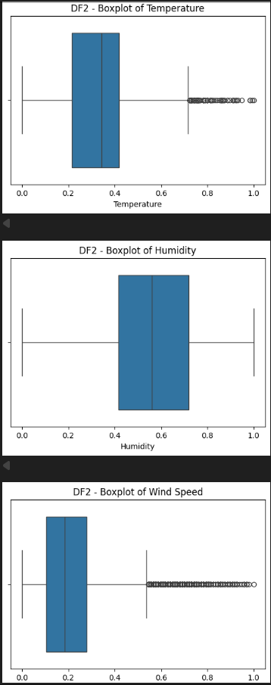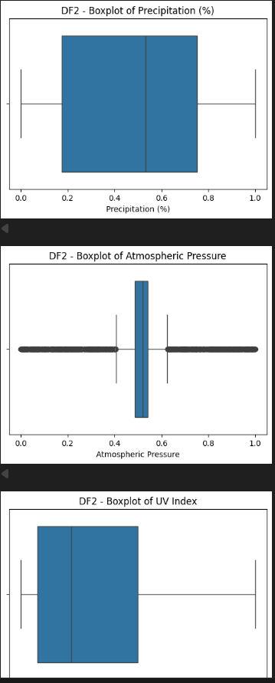

4. Model Building
- Logistic Regression → baseline, interpretable.
- Decision Tree → captures non-linear patterns.
- Random Forest → ensemble, improves generalization.

5. Model Evaluation
Model | Accuracy | Precision | Recall | F1-Score
Logistic Regression | 0.8659 | 0.8670 | 0.8659 | 0.8658
Decision Tree | 0.9038 | 0.9040 | 0.9038 | 0.9037
Random Forest | 0.9155 | 0.9159 | 0.9155 | 0.9156
- Logistic Regression: Strong baseline (86%).
- Decision Tree: Better (~90%), but risk of overfitting.
- Random Forest: Best (~91.5%), robust and balanced.

6. Conclusion
- Random Forest performed best overall.
- EDA confirmed key correlations (Humidity–Precipitation, Temperature–Visibility).
- Future work: hyperparameter tuning, advanced ensembles (XGBoost/LightGBM).

